**/*TE CMPN A-27*/**

**Expt : 10**

**Server:**

import java.io.*;

import java.net.*;

public class FTPServer

{

public static void main(String arg[])throws IOException

{

DataInputStream din;

DataOutputStream dout=null;

FileInputStream fin;

FileOutputStream fout;

BufferedReader br=new BufferedReader(new InputStreamReader(System.in));

ServerSocket ser=null;

int ch=0;

try

{

while(true)

{

ser=new ServerSocket(2345);

Socket s=ser.accept();

System.out.println("Connection Establishment");

din=new DataInputStream(s.getInputStream());

dout=new DataOutputStream(s.getOutputStream());

String file="";

String choice=din.readUTF();

if(choice.compareTo("GET")==0)

{

file=din.readUTF();

System.out.println("Client wants a file from me");

System.out.println("Requested file:"+file);

fin=new FileInputStream(file);

dout.writeUTF("File Exists");

while((ch=fin.read())!=-1)

dout.writeInt(ch);

fin.close();

System.out.println("File Transfered");

String reply=din.readUTF();

System.out.println(reply);

System.out.println("Connection Closed");

}

if(choice.compareTo("Send")==0)

{

System.out.println("Client wants to send me a file");

System.out.println("Enter Destination File");

fout=new FileOutputStream(new File(br.readLine()));

while((ch=din.readInt())!=-1)

fout.write(ch);

fout.close();

System.out.println("File Received");

dout.writeUTF("SERVER:Your file is uploaded on Server");

System.out.println("Connection close");

}

if(choice.compareTo("DISCONNECT")==0)

{

System.out.println("Client Disconnected");

System.exit(0);

}

}

}

catch(FileNotFoundException fnf)

{

System.out.println("Requested file not found");

dout.writeUTF("file not existing");

}

catch(SocketException se)

{

System.out.println("job done");

}

catch(Exception e)

{

System.out.println("error in connection");

}

}

}

**/*OUTPUT:**

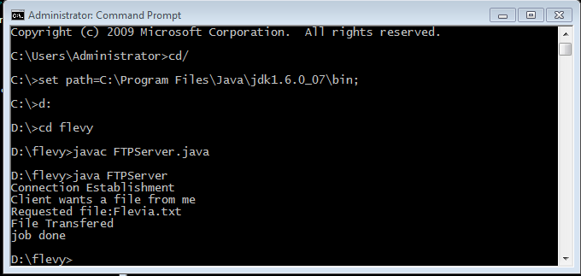

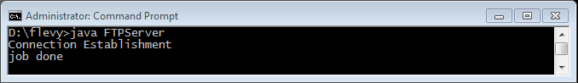

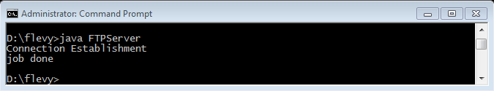

**\*/**

**Client:**

import java.io.*;

import java.net.*;

public class FTPClient

{

public static void main(String args[])

{

BufferedReader br=new BufferedReader(new InputStreamReader(System.in));

DataInputStream din;

FileInputStream fin;

FileOutputStream fout;

String file;

try

{

Socket cs=new Socket(InetAddress.getLocalHost(),2345);

din=new DataInputStream(cs.getInputStream());

int ch=0;

DataOutputStream dout=new DataOutputStream(cs.getOutputStream());

System.out.println("Enter the operation to be performed: \n1.GET \n2.SEND \n3.Disconnect");

int choice=Integer.parseInt(br.readLine());

switch(choice)

{

case 1:

{

dout.writeUTF("GET");

System.out.println("Enter the name of the file to be received");

file=br.readLine();

dout.writeUTF(file);

if((din.readUTF()).compareTo("File not existing")==0)

System.out.println("Server does not have requested file!!");

else

{

System.out.println("Enter Destination File:");

fout=new FileOutputStream(new File(br.readLine()));

while((ch=din.readInt())!=-1)

fout.write(ch);

fout.close();

dout.writeUTF("Thank you");

System.out.println("I have received the file");

}

}

break;

case 2:

{

dout.writeUTF("SEND");

System.out.println("Enter the name of the file to be uploaded");

fin=new FileInputStream(br.readLine());

while((ch=fin.read())!=-1)

dout.writeInt(ch);

fin.close();

String reply=din.readUTF();

System.out.println(reply);

System.out.println("File uploaded on Server");

}

break;

case 3:

{

System.out.println("Client Disconnect");

System.exit(0);

}

break;

default:

{

System.out.println("Wrong choice");

System.exit(0);

}

}

}

catch(FileNotFoundException fnf)

{

System.out.println("Requested file not found");

}

catch(SocketException se)

{

System.out.println("Job done");

}

catch(Exception e)

{

System.out.println("Error Connection"+e);

}

}

}

**/*OUTPUT:**

